**MODULE 5 ASSIGNMENT**

**DATA MODIFICATION**

**PROBLEM 3 :**

**1. MODIFICATION STATEMENT :**

**C:\Users\Hp\Contacts\Desktop\datawarhousing course\26.PNG**

**2. BEFORE THE INSERTION :**

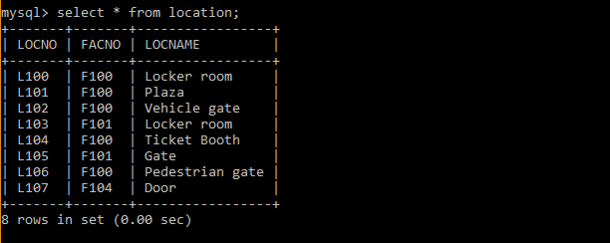

**3. AFTER THE INSERTION :**

